**Incredible Iceland Site Plan**

**Stephanie Monfredi**

**WDD 130**

**Overview**

**Purpose**

To show Icelands magical views and why it would be worth visiting.

**Audience**

Anybody who wants to go on a life changing vacation

**Branding**

**Website Logo**

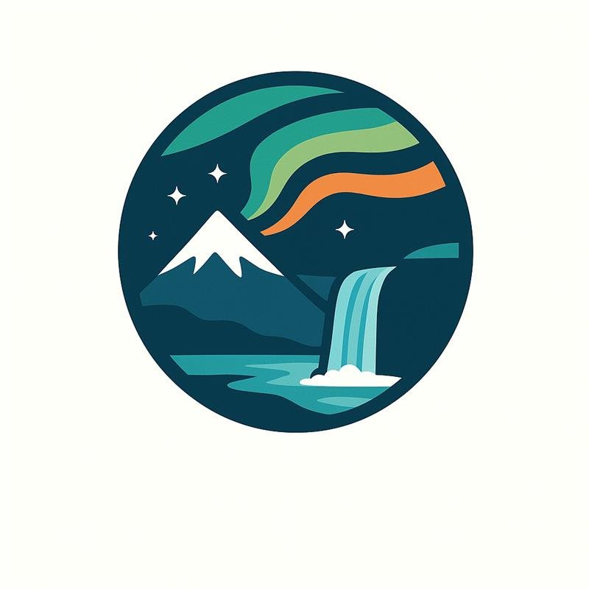

**Style Guide**

**Color Palette**

| **Primary** | **Secondary** | **Accent 1** | **Accent 2** |
| --- | --- | --- | --- |
| #073a4d | #7ed3d3 | #22a08e | #f08b43 |

**Use any colors that are in the Logo**

**Typography**

**Heading Font: "Montserrat", sans-serif;**

**Paragraph Font: "Nunito", "Open Sans", sans-serif;**

**You can find these on google fonts**

**Navigation**

Home Places to Visit Adventures

**Content**

**Welcome to Incredible Iceland**

Discover the breathtaking beauty, wild landscapes, and rich culture that make Iceland one of the most unforgettable places on Earth. Whether you're dreaming of glowing glaciers, powerful waterfalls, or colorful Northern Lights, our site will guide you through everything Iceland has to offer.

**On this website you’ll find:**

* The most stunning places to visit
* The top adventures and experiences
* Local insights and hidden gems

Start exploring and uncover why Iceland should be your next great adventure.

**Places to Visit**

**Must-See Places in Iceland**

**The Blue Lagoon**

A world-famous geothermal spa known for its bright blue water and relaxing atmosphere. Perfect for unwinding in naturally heated mineral pools.

**The Golden Circle**

A popular route featuring three major attractions:

* **Þingvellir National Park**
* **Geysir Geothermal Area**
* **Gullfoss Waterfall**

**Skógafoss & Seljalandsfoss**

Two of Iceland’s most iconic waterfalls — one powerful and towering, the other offering a path behind the falls for an unforgettable view.

**Reynisfjara Black Sand Beach**

A dramatic black beach known for its basalt columns and crashing Atlantic waves.

**Northern Lights Hotspots**

Visit places like Vík, Akureyri, and Thingvellir for the best chances to see the Aurora Borealis.

**Things to Do**

**Top Adventures & Activities**

**Glacier Hiking**

Explore Iceland’s icy landscape up close with guided tours on massive glaciers like Sólheimajökull.

**Volcano Tours**

Visit active volcanoes and learn about Iceland’s powerful geology shaped by fire and ice.

**Ice Cave Exploration**

During winter, discover brilliant blue ice caves carved by nature.

**Whale Watching**

Hop on a boat from Reykjavík or Húsavík to see humpback, minke, and sometimes orca whales.

**Hot Springs & Relaxation**

Soak in natural hot springs like the Secret Lagoon or Reykjadalur hot river.

**Taste Icelandic Food**

Try classics such as lamb stew, fresh seafood, hot spring bread, and skyr.

**Home**

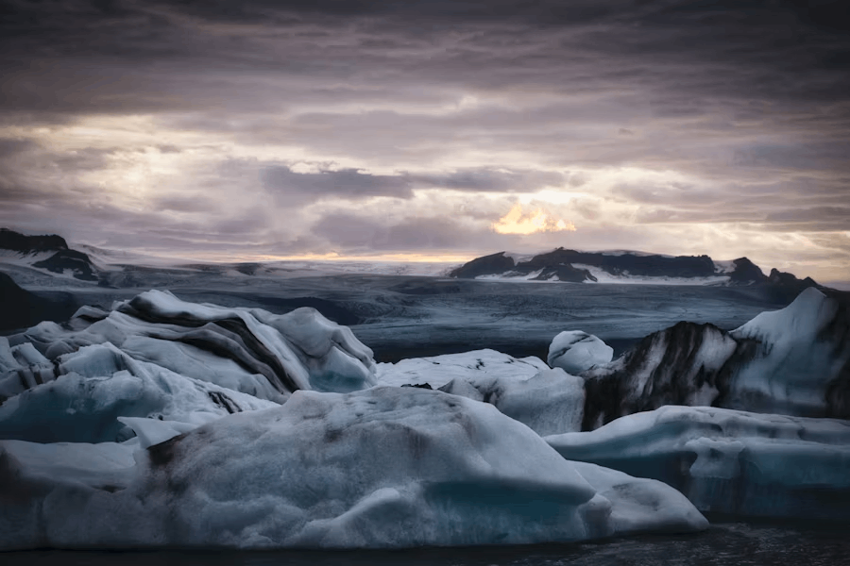

**Welcome to Incredible Iceland**

Discover the breathtaking beauty, wild landscapes, and rich culture that make Iceland one of the most unforgettable places on Earth. Whether you're dreaming of glowing glaciers, powerful waterfalls, or colorful Northern Lights, our site will guide you through everything Iceland has to offer.

**On this website you’ll find:**

* The most stunning places to visit
* The top adventures and experiences
* Local insights and hidden gems

Start exploring and uncover why Iceland should be your next great adventure.

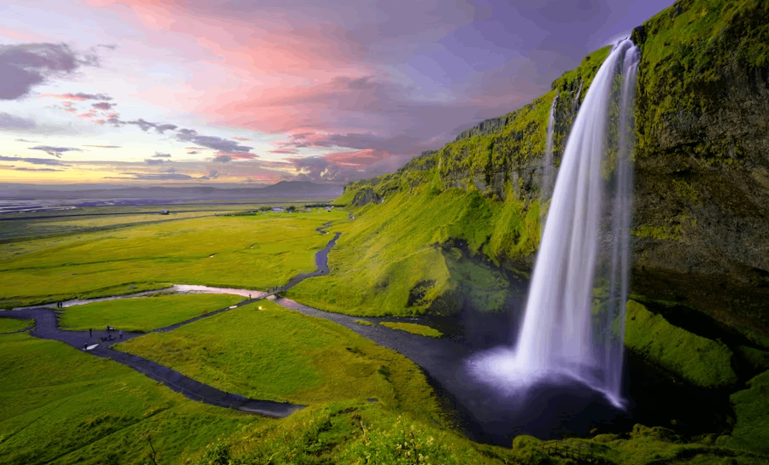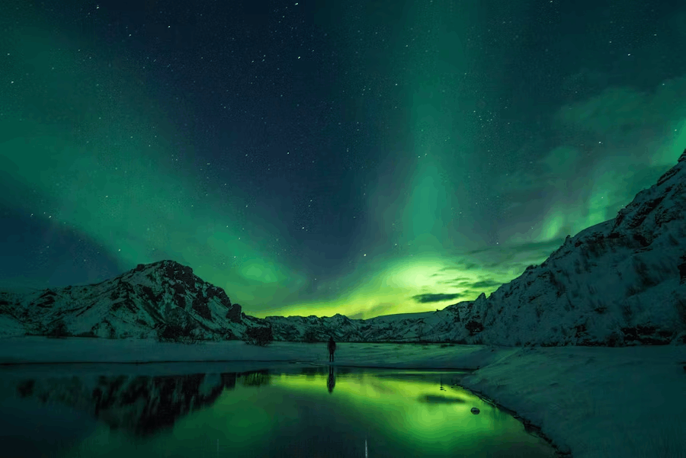

**Page 1**

**Must-See Places in Iceland**

**The Blue Lagoon**

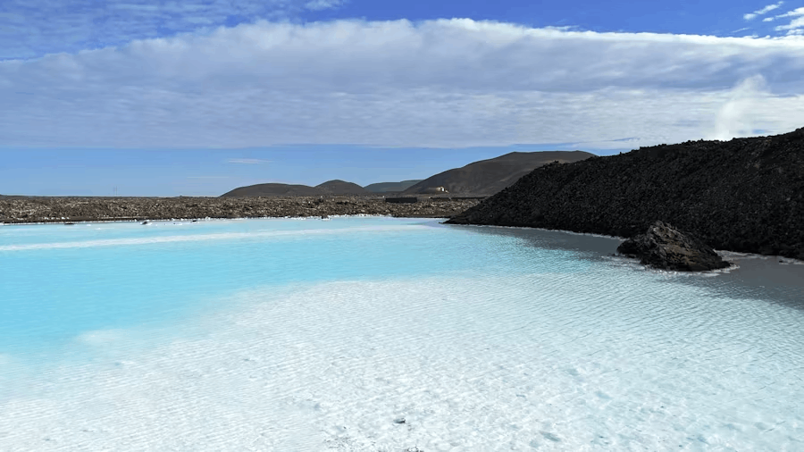

A world-famous geothermal spa known for its bright blue water and relaxing atmosphere. Perfect for unwinding in naturally heated mineral pools.

**The Golden Circle**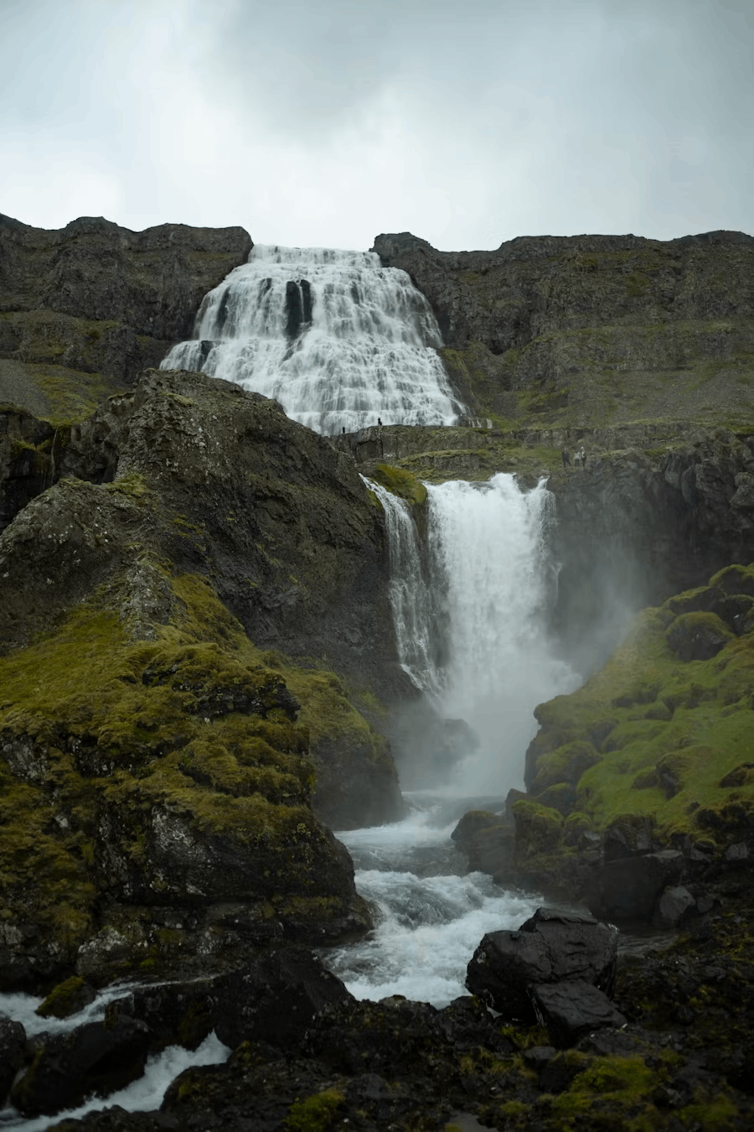

A popular route featuring three major attractions:

* **Þingvellir National Park**
* **Geysir Geothermal Area**
* **Gullfoss Waterfall**

**Skógafoss & Seljalandsfoss**

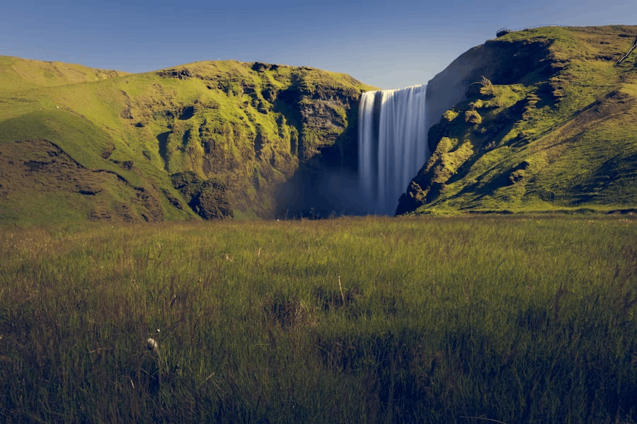

Two of Iceland’s most iconic waterfalls — one powerful and towering, the other offering a path behind the falls for an unforgettable view.

**Reynisfjara Black Sand Beach**

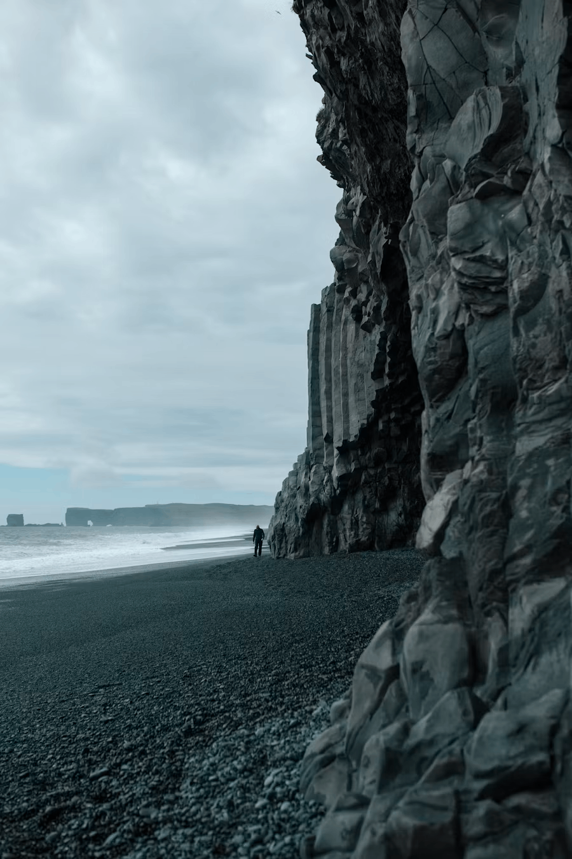

A dramatic black beach known for its basalt columns and crashing Atlantic waves.

**Northern Lights Hotspots**

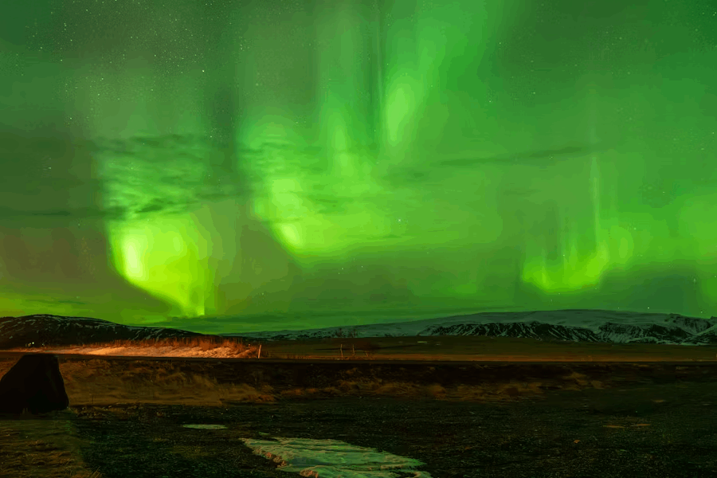

Visit places like Vík, Akureyri, and Thingvellir for the best chances to see the Aurora Borealis.

**Page 2**

**Things to Do**

**Top Adventures & Activities**

**Glacier Hiking**

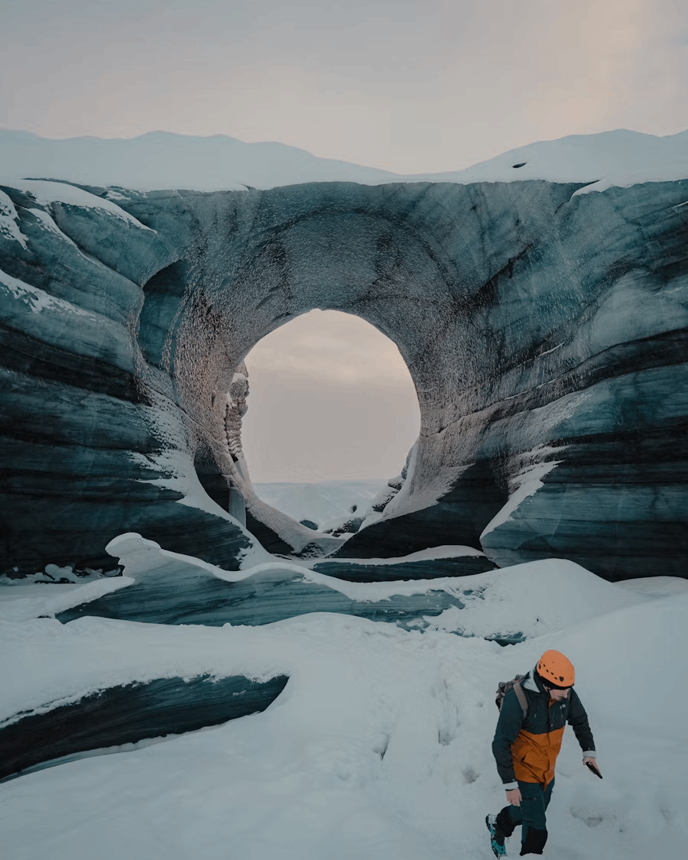

Explore Iceland’s icy landscape up close with guided tours on massive glaciers like Sólheimajökull.

**Volcano Tours**

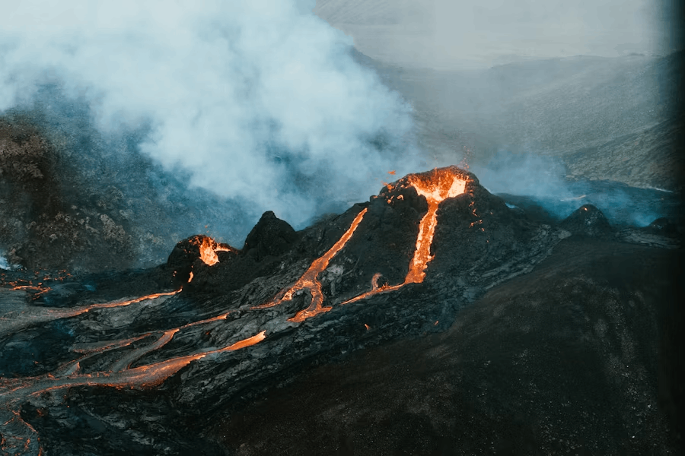

Visit active volcanoes and learn about Iceland’s powerful geology shaped by fire and ice.

**Ice Cave Exploration**

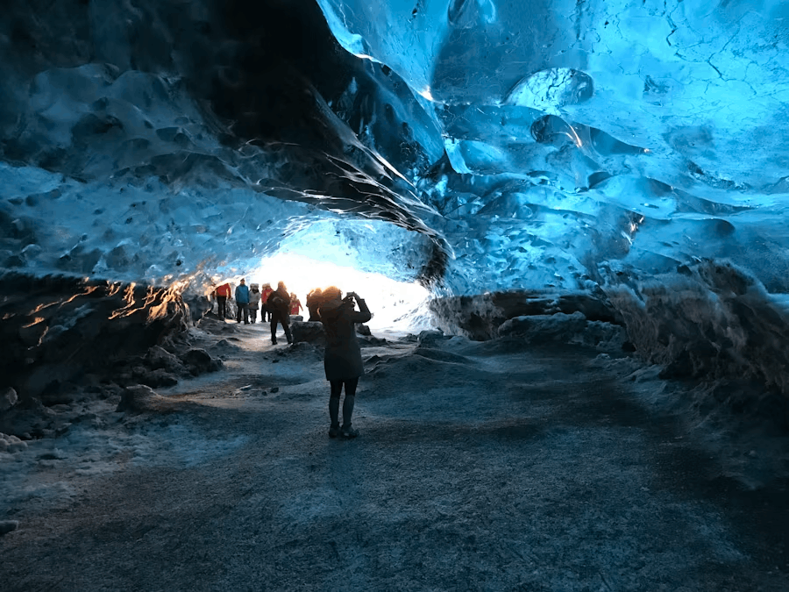

During winter, discover brilliant blue ice caves carved by nature.

**Whale Watching**

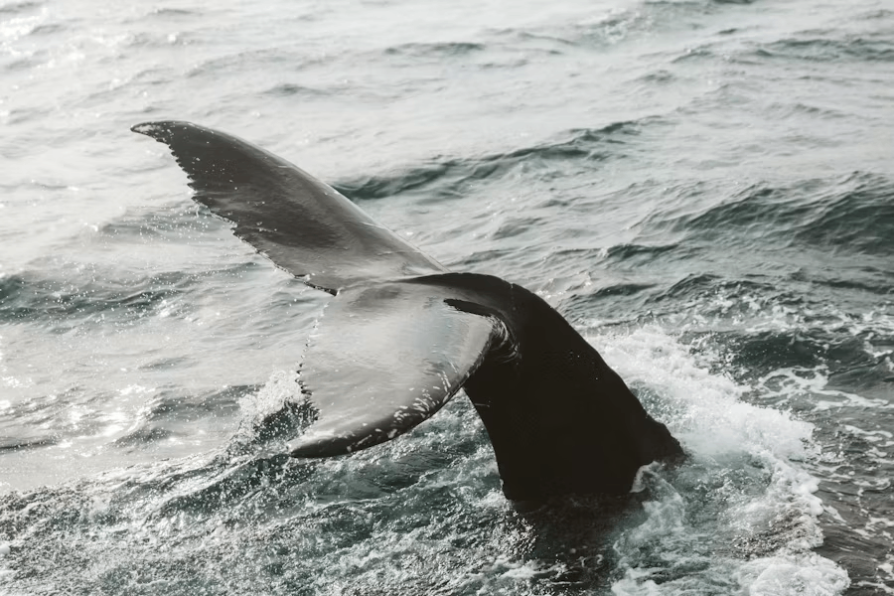

Hop on a boat from Reykjavík or Húsavík to see humpback, minke, and sometimes orca whales.

**Hot Springs & Relaxation**

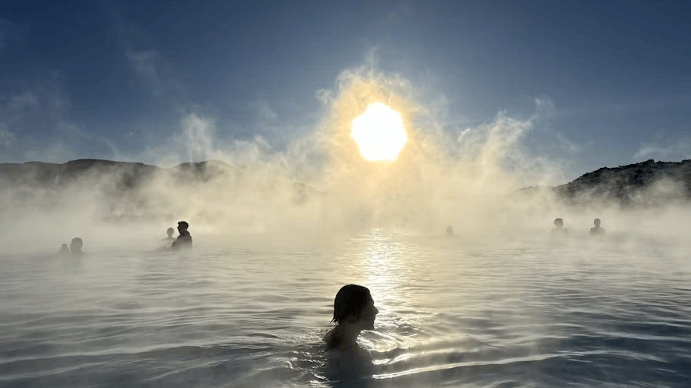

Soak in natural hot springs like the Secret Lagoon or Reykjadalur hot river.

**Taste Icelandic Food**

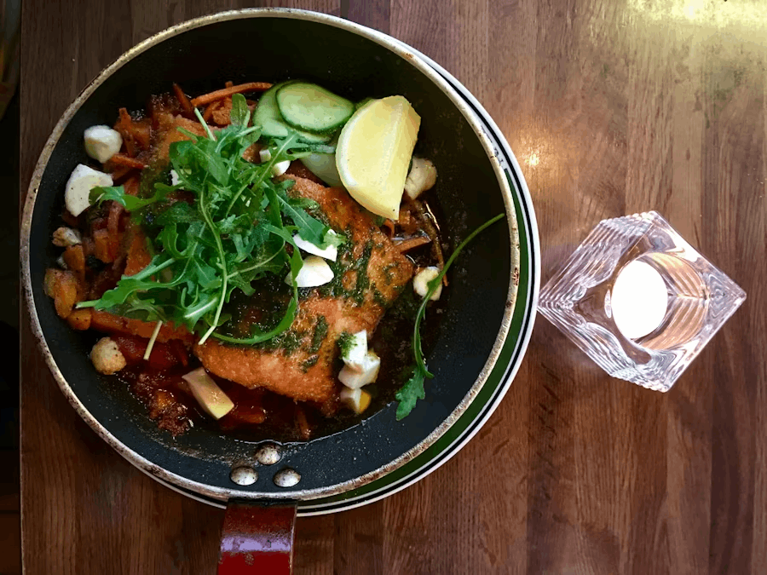

Try classics such as lamb stew, fresh seafood, hot spring bread, and skyr.

**Wireframes**

**Home Page Wireframe**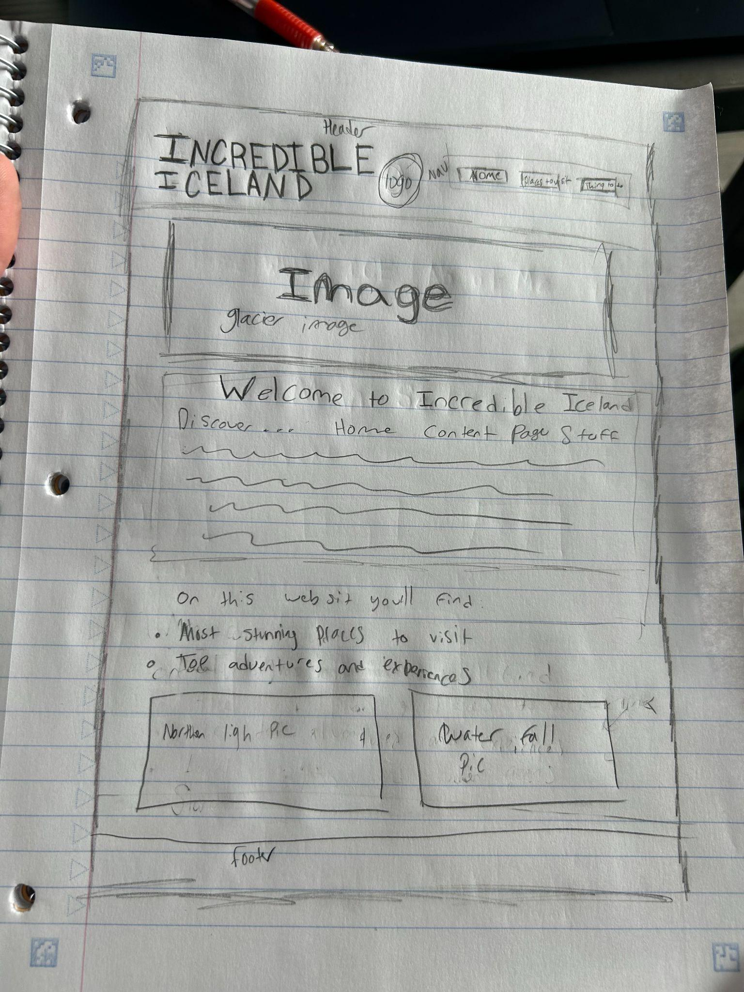

**Page 1 Wireframe**

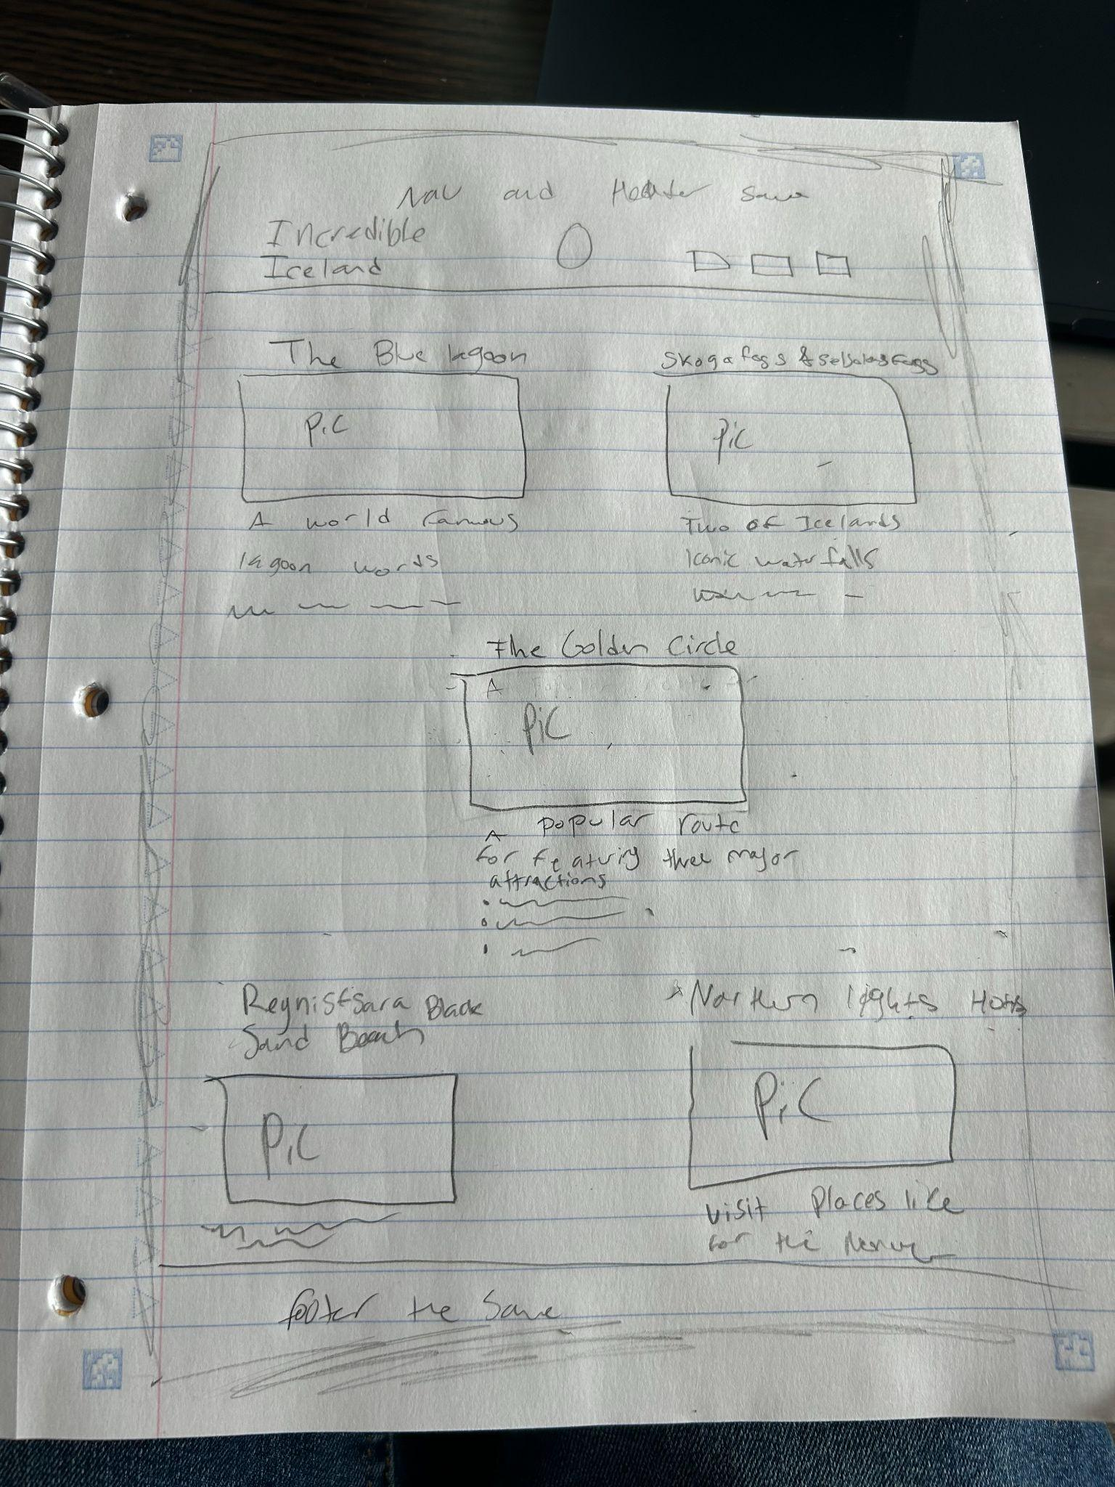

**Page 2 Wireframe**

